Although we don’t usually wear uniform on a Monday night, we will occasionally and certainly on other occasions away from our regular programme.

All you will need to do is get the Explorer shirt and I will take care of the rest at your investiture (badges and scarf). We will try to invest you within the first term, until you are invested, you aren’t really a member so do get the uniform ASAP.

Uniform is available from Scout Park, school uniform shops, Amazon, the scoutshop online and probably several other places...

Explorer Scout Long Sleeve Shirt
Explorer Scout Long Sleeve Shirt
This lightweight, loose fit Explorer long sleeve shirt is a cool alternative for the summer and is a key element of the Explorer uniform.
 |  |  |  | View on shop.scouts.org.uk | Preview by Yahoo

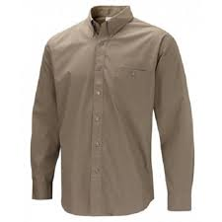

If you are struggling then please contact me and I can help.

As a general point, do please contact me whenever you are unsure of anything, if I don’t answer the phone due to being at work then I will call back, my number is 07977 185981. If you are not getting emails then PLEASE contact me because it is the main source of information.
Yours in Scouting,
Dan
(Hatters ESL)
hatters@southgate-explorers.org.uk

